**Game Design Studio Two**

**“Mowdown”**

**Team Four**

Report for Sprint One

10 / AUG / 2015 – 23 / AUG / 2015

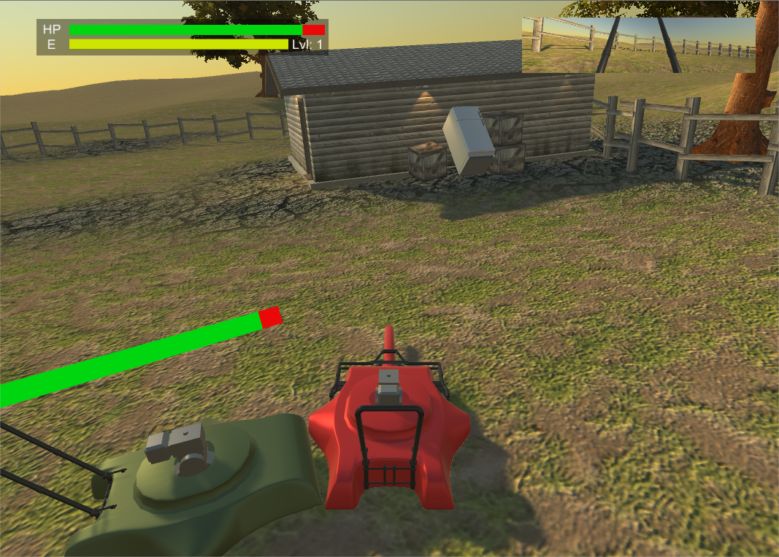

**Team Members:**

Matthew Carver –12028130

Deinyon Davies – 11688025

The most honoured Master of the Scrum,SirRobert McClelland –11743693

Dinh Bao Anh (Brendan) Vo – 11437237

Jesse Walker – 11729631

**SPRINT PLAN AND EXECUTION**

For this first scrum of the project “*Mowdown*”, the team committed 13 tasks to the Sprint Log at the preliminary meeting. The Sprint Log proposed a total estimated investment of 840 minutes, with an estimated median task duration of 50 minutes. Having completed the sprint backlog, it was discussed that the team had likely neglected several critical tasks, and as such, the backlog would soon be expanded. The sprint would optimally be completed in 490 minutes.

During the execution of the scrum, 9 critical and prerequisite tasks became apparent, which were completed and appended to the Sprint Log when necessary. The auxiliary tasks assumed an additional estimated duration of 290 minutes, expanding the total estimated sprint workload to 1,130 minutes.

At Sprint finalisation, the Sprint Log totalled 22 expected and unexpected tasks. The team observed a total logged workload **1,165 minutes** (19.42 hours).

**SCRUM MEETING LOGS**

**10 / AUG / 2015**

**4:30pm – 6:00pm**

**Location:** UTS Building 11, Game Design Studio Laboratory

**Members present:** Brendan, Deinyon, Jesse, Matthew, Robert

The team identified backlog items and discussed time estimates.

**11 / AUG / 2015**

**11:30am - ~10:00pm**

**Location:** Electronic Discussion via Facebook

**Members present:** Deinyon, Jesse, Robert

Discussion of the Unity NavMesh API, and propositions for the application of the CalculatePath() functionality in order to program an application-specific NavMesh Agent, eventually to be manipulated by a Finite State Machine. Subsequent discussion of how the AI will respond to waypoints that greater than 180O from the AI vehicle’s forward vector.

**11 / AUG / 2015**

**2:30pm ~ 7:00pm**

**Location:** Electronic Discussion via Facebook

**Members present:** Brendan, Deinyon, Jesse, Matthew, Robert

Presentation and discussion of four character model (lawnmower) design prototypes, each presenting distinct stylistic properties. Three of four members expressed preference for the mildly-stylised design (“The Standard”).

See the following figure for the four design prototypes:

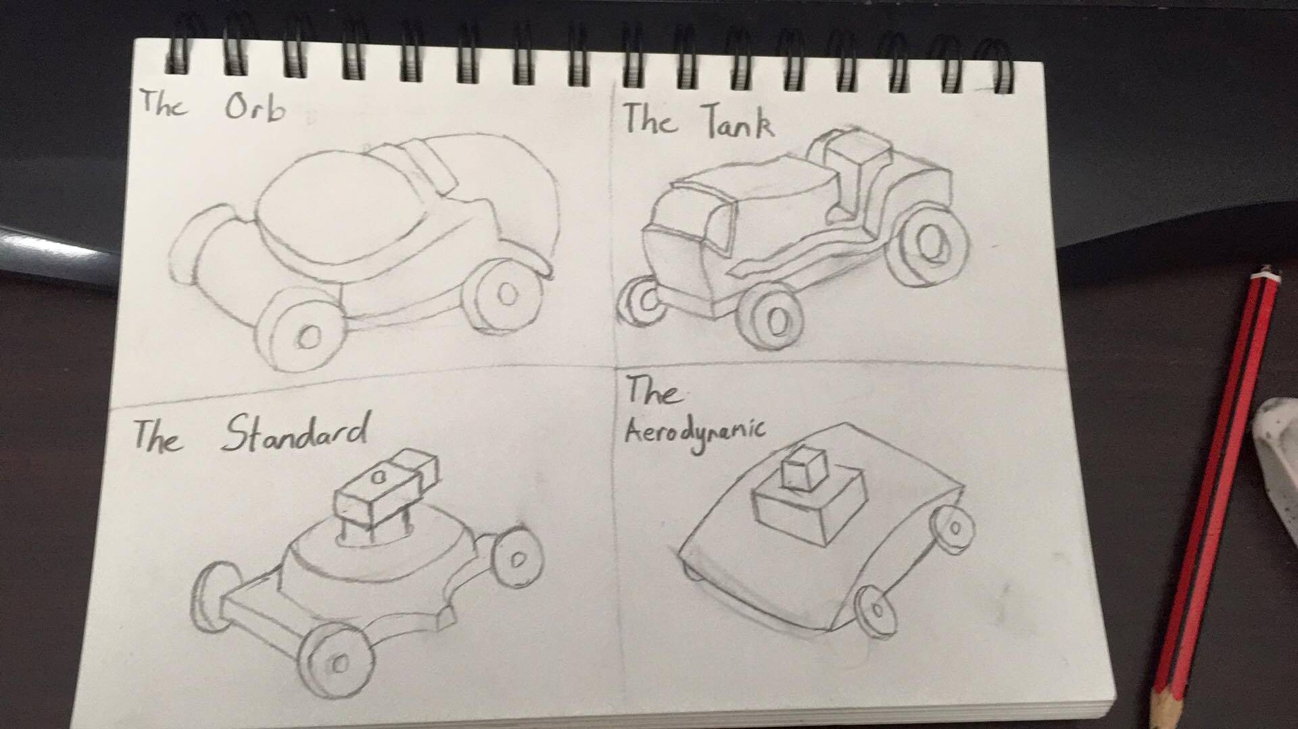

**13 / AUG / 2015**

**6:00pm – 14 / AUG / 2015 at 11:30am**

**Location:** Electronic Discussion via Facebook

**Members present:** Deinyon, Jesse, Robert

Initial presentation of Level One design, as well as discussion regarding design style. The following figure is the initial Level One design.

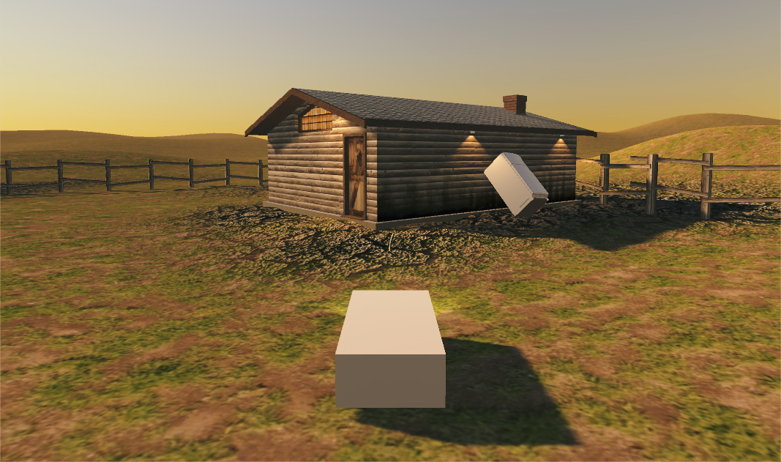

**15 / AUG / 2015**

**5:00pm – 6:00pm**

**Location:** Electronic Discussion via Facebook

**Members present:** Deinyon, Robert

Discussion of initial random-number based damage mechanics implementation.

Subsequent discussion of maintaining several concurrent version control branches for disjoint work. Team members concluded that distributing workload into several branches during project development would mitigate merging issues.

**15 / AUG / 2015**

**8:00pm – 10:00pm**

**Location:** Electronic Discussion via Facebook

**Members present:** Deinyon, Matthew, Jesse

Presentation and discussion of modified damage logic which employs the angle between the collision incident point and the opponent in order to issue more damage for side collisions.

Team members also discuss how equal-mass and equal-angle collisions should deal damage to players and opponents. Discussion resulted in the collective opinion that the mower with the higher velocity should deal the majority of damage to its opponent.

**16 / AUG / 2015**

**4:00pm – 5:00pm**

**Location:** Electronic Discussion via Facebook

**Members present:** Brendan, Deinyon, Matthew, Jesse

Presentation of work-in-progress lawnmower model. Team members discuss the separation of mesh components for interfacing with animation and component-selection code.

See the following figure of the prototype character model.

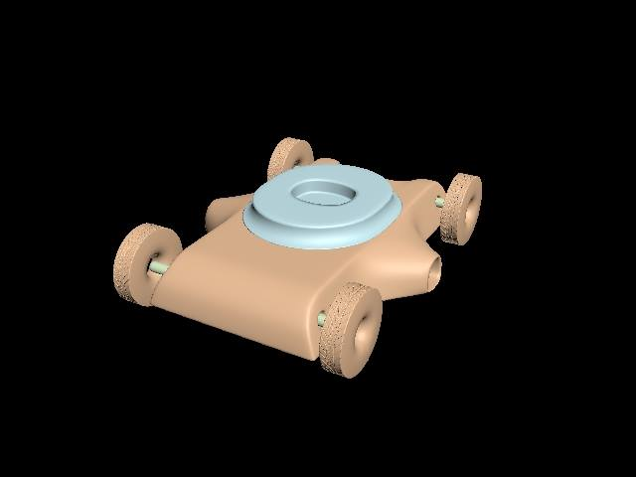

**16 / AUG / 2015**

**4:00pm – 6:00pm**

**Location:** Electronic Discussion via Facebook

**Members present:** Brendan, Deinyon

Discussion of improved health and experience meters, as well as the floating (not yet billboarded) mini-health-bar.

**22 / AUG / 2015**

**7:00am – 12:00pm**

**Location:** Electronic Discussion via Facebook

**Members present:** Deinyon, Robert

Discussion of Xbox 360 Controller implementation, and “boost system”.

**23 / AUG / 2015**

**8:00pm**

**Location:** Electronic Discussion via Facebook

**Members present:** Brendan, Deinyon, Jesse, Matthew, Robert

Demonstration of modified vehicle attachment models including the mower handle and spike attachment (see figure).

Continued team discussion on project closure and final bug-fixing and feature implementation.

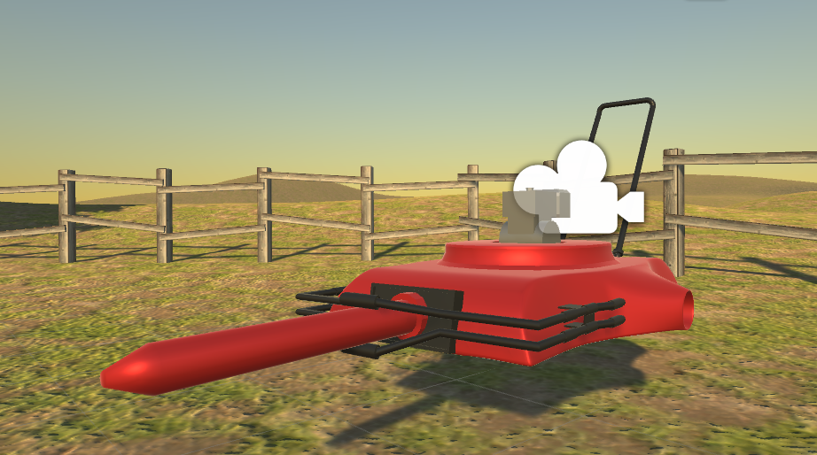

**BURNDOWN CHART**

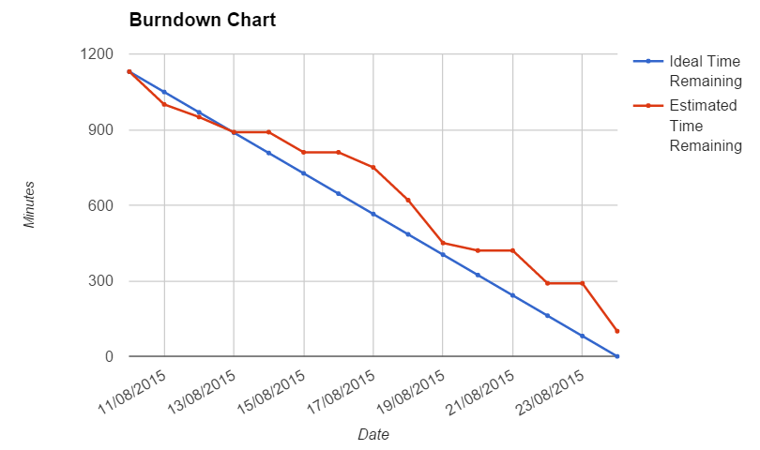

**REFLECTION**

Sprint One of the Mowdown project was a success. As illustrated by the Burndown Chart, development was closely constrained to the ideal path, with work completed on a regular, nearly daily basis. A significant workload was completed on the first day of Sprint One as the result of associated research and testing that was completed prior to formal project initiation.

All team members contributed significantly to the project, observing excellent communication and collaboration skills. Teamwork was simplified through the decision to allocate several parallel version control branches to distinct tasks; merging disjoint components from multiple team members did not interfere with the work of any other member, as members were mostly bound to their own branch during development until merging into the master branch was necessary.

**SPECIAL CIRCUMSTANCES**

N/A

**VERSION CONTROL COMMIT LOG**